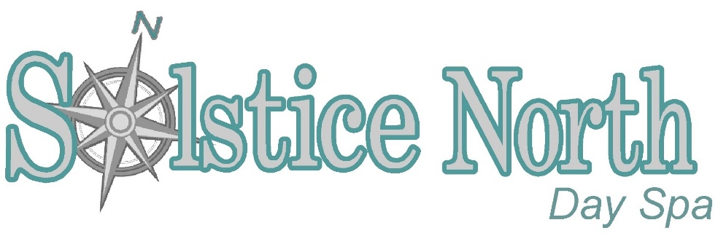
Spa Party Payment Agreement & Cancellation Policy

Thank you for considering Solstice North Day Spa for your group spa & salon services. We hope that we can accommodate you and your party’s individual needs. To help us serve you better, below is a list of things we will need to start the process of scheduling your party:

1) Host/Hostess name and contact information, including phone #, address and email
2) The first and last names of the people wanting to receive services.
3) The services they would like to receive and their second choices.
4) A date and time frame that work for you.
5) An initialed and signed copy of our Policy & Payments Agreement emailed back to us manager@solsticenorth.com. A photo of the signed agreement is the preferred method.

Spa Party Payment: 50% deposit is due upon reservation for groups of 5 people or more. Payment in full is required 1 week prior to the party. Additional appointments requested on the day of the event are subject to availability and can be paid for on the day of service.
Confirmed Booking & Schedule: Once the deposit has been received parties will receive an itinerary of the day’s appointments with requested services, start times, and cost. All appointments are subject to our Cancellation and Lateness policies (below). The Host/Hostess will also receive a detailed invoice, for payment and scheduling purposes. It is important to note that to make sure everything goes smoothly that everyone arrives on time and is ready for their scheduled services. Guests should arrive 15 minutes prior to the start of their treatments to fill out intake forms, relax and get changed into robes as necessary. It is not always possible to switch appointment times or services around on the day of to accommodate late guests.
Cancellations: Cancellations for parties are required two weeks prior to the date of services being received. If cancellation is given in proper time frame the Host/Hostess will be refunded the 50% deposit. Cancellations 13days-7days prior will forfeit the 50% deposit. Cancellations less than 1 week forfeit the payment in it’s entirety.
No Shows/Lateness: In order to effectively accommodate your group your promptness is required and appreciated. We cannot guarantee appointments for party members arriving more than 10 minutes past their scheduled appointment times. If time allows, the client will have the option of accepting an abbreviated version of the scheduled service at no discount. If someone is unable to attend, a substitute guest may come in place of the person cancelling for the same services at the same time or another guest may receive their services if they do not conflict with their own scheduled appointments.

Gratuities: Gratuities are NOT included in the service prices but are greatly appreciated! Gratuities may be paid in cash or with credit card on the day of the services.
Etiquette: We recognize this is your special time and you want your guests to have fun and relax, but we must ask that all party guests remember that not everyone having services that day is in your party. Because we want all clients to receive wonderful treatments, we ask that you and your guests respect our no cell phone policy, speak in “spa” voices, and keep from congregating in high traffic areas. Rowdy or disruptive behavior will not be tolerated. If any member of your party is inconsiderate of these policies, they will be asked to leave and no refund for scheduled services will be given. If you are organizing a large party and would like to have the spa to yourself, private parties are available in advance and are subject to availability. Private parties have minimum requirements that can be discussed at time of request.
Unfortunately, we cannot allow guests to bring food unless it is a private party. If you would like to bring in food (private party) or beverages (any spa party), they must first be cleared with management.
By signing this form, you agree to all the above guidelines and make it my responsibility to pass this information along to all the members of the party. This contract is a binding agreement for service between the host/hostess and Solstice North Day Spa.
If you have any questions, please email them to manager@solsticenorth.com.

Sign: ___________________________________________ Date:____________________

